Are you a boy or a girl? Draw your face.
¿Eres un chico o una chica?, Dibuja tú cara.

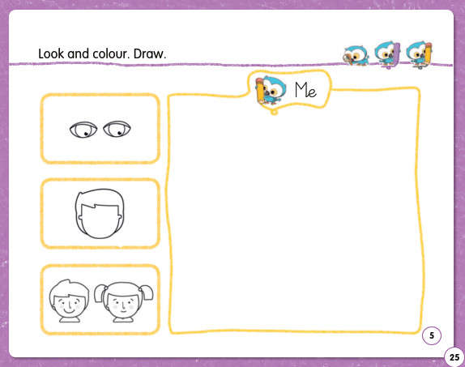

Sing and learn, Five little monkeys jumping on the bed.
https://www.youtube.com/watch?v=2j6T4ad1oQU

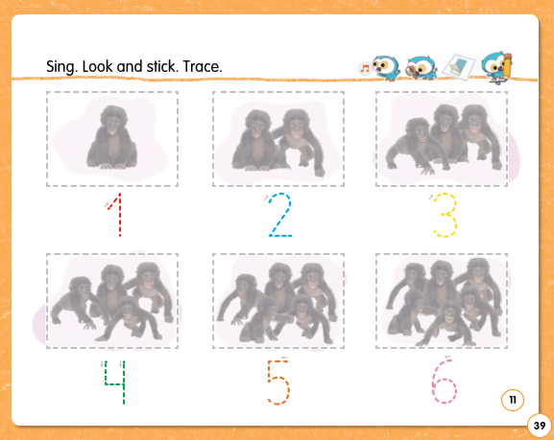
Colorea y repasa los trazos.

